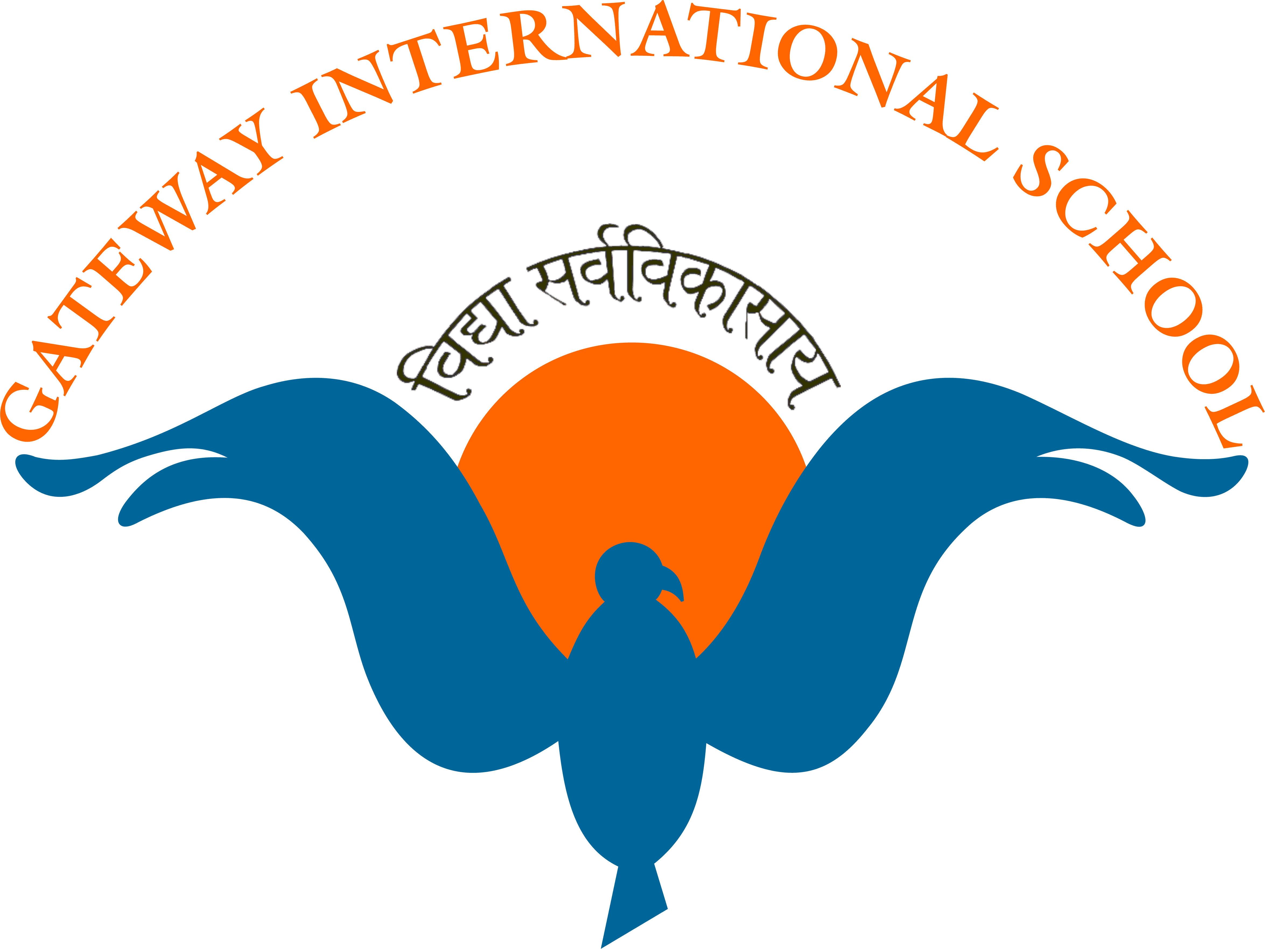
GATEWAY INTERNATIONAL SCHOOL
Sector 11, Sonepat 131001
Ref No: GIS/2013-14: 38 Date 4 Dec, 2013
Dear Parent,
Greetings from Gateway International School!
DATE SHEET FOR PREBOARD AND INTERNAL ASSESSMENT:
1st Pre Board/2nd Internal assessment
Date | XI SCIENCE/COMMERCE | XII SCIENCE/COMMERCE
11/12 | Regular Classes | Prep leave
12/12 | Regular Classes | Prep leave
13/12 | Business studies/Chemistry | English
14/12 | Holiday (2nd Saturday) | Holiday (2nd Saturday)
15/12 | Sunday | Sunday
16/12 | Maths/Bio | Business Studies
17/12 | Regular Classes | Prep Leave
18/12 | Physics/Accounts | IP/FA/PH.ED.
19/12 | Regular Classes | Prep Leave
20/12 | IP/FA/PH.ED. | Economics
21/12 | English | Prep Leave
22/12 | Sunday | Maths(Stress Buster)/Bio
23/12 | Economics | Prep Leave
24/12 | Regular Classes | Prep Leave
25/12 | Christmas holiday | Physics/Accounts(Stress Buster)
26/12 | Regular Classes | Prep Leave/Regular classes for 12 Comm
27/12 | Regular Classes | Prep Leave/Regular classes for 12 Comm
28/12 | PTM | Prep Leave
29/12 | Sunday | Chemistry(Stress Buster)
2nd Pre Board
Dates | 12 Science | 12 Commerce
7/1 | Prac Exam IP/FA/PH.ED. | Prac Exam IP/FA/PH.ED.
8/1 | Prac Exam Biology | Prac Exam Business Studies
9/1 | Prep Leave | Prep Leave
10/1 | Chemistry | Business Studies
11/1 | Prep Leave | Prep Leave
12/1 | Sunday | Sunday
13/1 | Physics | Accounts
14/1 | Prep Leave | Prep Leave
15/1 | English | English
16/1 | Prep Leave | Prep Leave
17/1 | IP/FA/PH.ED | IP/FA/PH.ED
18/1 | Prep Leave | Prep Leave
19/1 | Sunday | Sunday
20/1 | Maths/Biology | Maths
21/1 | Prep Leave | Prep Leave
22/1 | Prac Exam Chemistry | Economics(Theory)
23/1 | Prac Exam Physics | Prac Exam Accounts
Kindly note the following:
School timings for classes 11, 12 during exams: 8:30 to 2:00 pm, Self commuters of class 12 can leave after answering their exam. School Transport will ply as usual.
Regards,
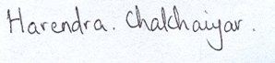
Principal, GIS

GATEWAY INTERNATIONAL SCHOOL
Sector 11, Sonepat 131001
Ref No: GIS/2013-14: 38 (a) Date 4 Dec, 2013
Dear Parent,
Greetings from Gateway International School!
Costumes will be sent through your ward on 5th December, 2013. In case some minor alteration is required we request you to get this done. Please send these costumes through your ward on the 6th of December, 2013. Also send them in the school bag. After this costumes will be kept in school. On 6th and 7th of December, 2013 all students must come to school in winter school uniform.
A deduction of Rs 135/- will be made from the tuck shop amount for costumes.
On 5th December, 2013 there will be no classes for 11, 12 and non-participating students. Only participants and volunteers need to attend. Classes Pearl to 10 will attend school as usual.
On the 6th of December, 2013 the following schedule will be followed for Annual Day rehearsals:
For classes 1 to 12:
- Reporting time: 2 p.m.
- Departure time: 7:30 p.m.
- Evening snacks and dinner will be provided
- There will be no classes for classes 11 , 12 and non participating students
- Only participants and volunteers need to attend
For Pearl, Ruby and Diamond:
- Reporting time: 3:30 p.m.
- Departure time: 5 p.m.
- Evening snacks will be provided.
Buses will ply accordingly for those who avail school transport.

On the 7th of December, 2013:
For classes 1 to 12:
- Reporting time: 2 p.m.
- Departure time: Please collect your ward after the entire programme is over, and before dinner.
For Pearl, Ruby and Diamond:
- Reporting time: 3:30 p.m.
- Departure time: Please collect your ward after the entire programme is over, and before dinner.
Buses will ply for those who avail school transport only for bringing children to school.
Evening snacks and dinner will be provided on this day.
Further, please refer to the almanac for any specific requirement for a particular event. For further queries please call +91 9812302372/0130-2218847
Looking forward to a great Annual Day!
Regards,
Principal, GIS

